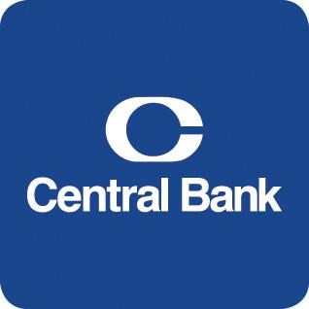

ACH User Guide

Commercial Online Banking Video Tutorials are located on our website at the following web address: https://www.centralbank.com/commercial-online-banking-video-tutorials. You may also access the Video Tutorials by accessing www.centralbank.com/Customer Service/Commercial Online Banking Video Tutorials.
March 19, 2026

Table of Contents
About ACH 1
2026 NACHA Operating Rules Updates 1
ACH User Setup 3
Approval Access 4
Payment Permissions 4
Access Schedule 5
User Entitlements 6
Methods of Creating your ACH 7
Creating a Template 7
Creating a Batch from a Template 11
Editing a Template 14
ACH Quick Entry 14
Prenotes 15
Export 16
Approve Payments 16
ACH File Import and ACH File Upload 17
ACH File Import – Recipients 18
Creating an Import Profile – Recipients 18
ACH File Upload 19
Manage File Uploads 19
General Information 20
Central Bank Holiday Schedules 20
Mobile Token 20
Additional Information 21

About ACH
Commercial Online Banking enables ACH origination, approval and release, as determined by your company’s entitlements. This module may be accessed either through the Commercial Online Banking website or the CentralMOBILE Business mobile application (app). The security code from a mobile or physical token is required to release ACH transactions.
Access Central Bank’s website at www.centralbank.com, Business, Cash Management Services to review the most current version of the Terms and Conditions to the Master Treasury Management Service Agreement where all services are further outlined.
Capitalized terms used and not otherwise defined in this ACH User Guide will have the meanings given them in the Master Treasury Management Service Agreement.

2026 NACHA Operating Rules Updates
The National Automated Clearing House Association (NACHA) is implementing rule amendments in 2026 to improve fraud monitoring and risk management across the ACH network. Under the existing Master Treasury Management Services Agreement, Company is required to comply with the NACHA Rules and may be held financially responsible for any fines or penalties incurred as a result of noncompliance. As a result of these ongoing contractual obligations, Company is bound to comply with the forthcoming 2026 NACHA Risk Management and Fraud Monitoring rule amendments as detailed below.
Note: This guide is provided as a summary of key information and is not intended to be a replacement or substitution for the full NACHA Operating Rules. In the event that any provision of this User Guide or the Master Treasury Management Services Agreement contravenes or conflicts with the current or future NACHA Operating Rules, the applicable agreements and procedures shall be deemed amended to the extent necessary to comply with the NACHA Rules. In all cases of discrepancy between the information provided in this User Guide or your agreements with Central Bank and the official NACHA Rules, the official NACHA Rules shall govern the processing of all ACH transactions
The NACHA rule amendments will roll out in two phases.
Phase 1: Effective March 20, 2026
- Phase 1 applies to all ODFIs, regardless of size. It also applies to non-consumer Originators, TPSs, and TPSPs that originated 6 million or more ACH entries in 2023, and to RDFIs that received 10 million or more ACH entries in 2023.
- Where applicable, you must have established and implemented documented, risk-based processes to monitor for and identify ACH entries initiated due to fraud, including “False Pretenses” (e.g., payments induced by deception). All originators, regardless of volume, must use specific standardized Company Entry Descriptions (see Creating a Template below).
- For more Phase 1 information, visit NACHA.
Phase 2: Effective June 19, 2026 (Enforced June 22, 2026)
- Phase 2 eliminates the volume thresholds entirely, applying to all remaining non-consumer Originators, TPSPs, and RDFIs that did not meet the Phase 1 volume thresholds.
- All remaining ACH network participants must comply with the NACHA mandate to establish, implement, and annually review your risk-based fraud monitoring processes and procedures.
- For more Phase 2 information, visit NACHA.
Risk Management Rules: You are required to establish, implement, and maintain risk-based processes and procedures, relevant to the role you play in the authorization or transmission of entries, that are reasonably intended to identify entries suspected of being unauthorized or authorized under False Pretenses. “False Pretenses” is defined as the inducement of a payment by a person misrepresenting (a) that person’s identity, (b) that person’s association with or authority to act on behalf of another person, or (c) the ownership of an account to be credited. This encompasses fraud scenarios such as business email compromise, vendor impersonation, and payroll redirection. To align with industry expectations for risk-based processes, consider implementing the following controls:
- Independent Verification: When adding a new recipient or editing an existing recipient’s banking information, you must verify the account change request through an independent channel. If an employee or vendor requests a change via email, always call a known, trusted phone number on file to confirm the change before updating the template in the system.
- Segregation of Duties (Dual Authorization): The individual establishing or altering payee bank details, or creating an ACH batch, should be separate from the individual who approves and releases the payment.
- Anomaly Detection: You should establish activity baselines and monitor for atypical payment requests, sudden increases in transaction volume, or abnormal transaction patterns.
- Secure Data Transmission: Sensitive account information (such as routing and account numbers) must be protected by rendering it unreadable when stored electronically, and must be securely transmitted via encryption.
- Incident Response: You must document specific steps for investigating suspected fraud, escalating issues internally, and establishing recovery procedures if fraudulent entries are initiated.
Annual Review: You are required to review your risk-based processes and procedures at least annually and make appropriate updates to address evolving risks.
To appropriately manage exposure, Central Bank reserves the discretion to conduct periodic reviews of your ACH services. Central Bank may request additional verification, financial information, or documentation at any time, particularly to evaluate risk limits, accommodate requests for increased transaction volumes, or monitor higher-risk origination activities.

ACH User Setup
For users to create, modify, or release ACH transactions, the proper access to ACH must be granted. Follow the directions below to grant ACH permissions.

Click Administration on the horizontal toolbar.

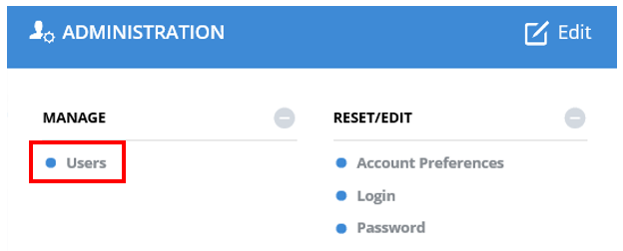
Click Users, located under Manage.

Click the down arrow next to the User Name.

Select Edit User.

Click Next to move to Step 3, Modify Privileges.

Approval Access
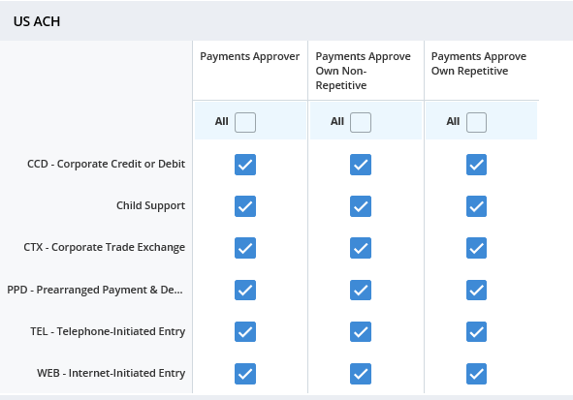
To enable Approvals, click Custom. Then click Set Approvals, and select US ACH. Once granted, the specific features for which approvals are enabled must be defined. Select the approval privileges for the user, and then click Submit.

Payment Permissions
Payment limits define a user’s customized limits for transactions and approvals.

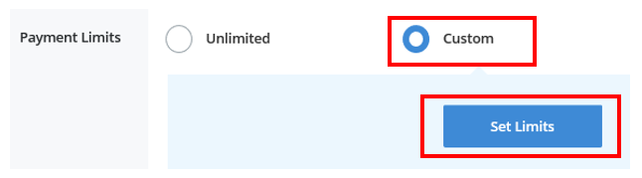
Under Payment Limits, select Custom to specify specific limits for a user, otherwise leave the selection to Unlimited to default to the company limits.

If Custom is selected, click Limit Settings, click either Standard or Extended. Enter the approved limits for each applicable ACH type. Specify limitations related to transaction amount, approval amount, or daily cumulative (definitions provided below).
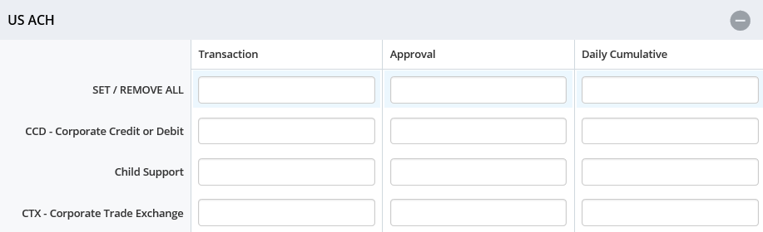
Transaction
The maximum amount for a transaction for the corresponding payment type.
Approval
Maximum amount user can approve for processing. If the transaction is over the amount the user cannot approve the transaction.
Daily Cumulative
Maximum amount user can submit for processing in a single day
Extended Transaction Non-Repetitive
The maximum amount for a transaction for the corresponding payment type.
Transaction Repetitive
The maximum amount for a transaction for the corresponding payment type
Approval Non-Repetitive
Maximum amount user can approve for processing for non-repetitive transactions.
Approval Repetitive
Maximum amount user can approve for processing for repetitive transactions
Daily Cumulative
Maximum amount user can submit for processing in a single day

Click Submit.

Access Schedule
If access to the system by a user needs to be modified, this can be accomplished through the Access Schedule. Select either Unlimited or Custom. Custom enables the restriction of the days and hours the user can access the system.

Custom:

Choose Set Access located under Access Schedule. Enter the times/dates the user should have access.

Click Save.
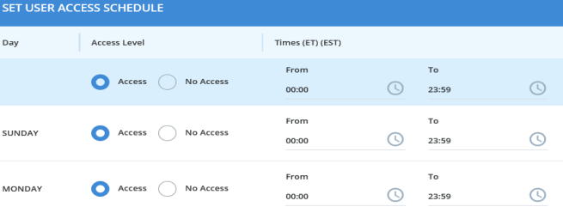

User Entitlements
None User does not have entitlements to any account or functions.
Custom User has customized entitlements
Full User has full access to all associated accounts and functions
To grant User Entitlements, click Custom. To grant full access to all accounts for a user, select Full.

Custom:

Select Custom, then click Save.

A green box will appear, select Custom.
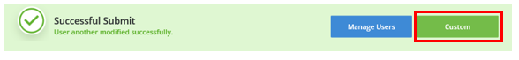

Click on Set Account Access to customize any account access for a user.

Select Set Functional Access to grant permissions for the user. Once the access has been granted, click Save.
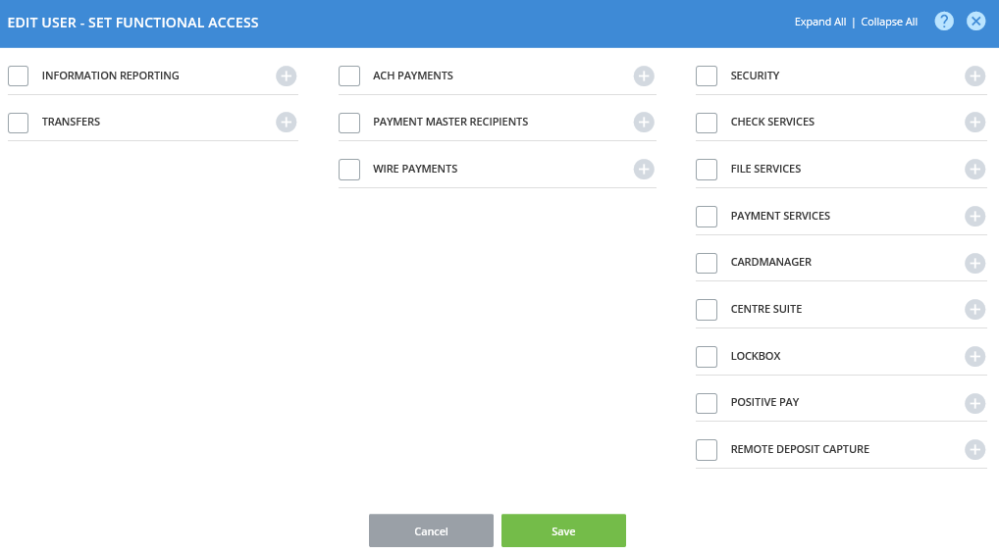

Click Set Data Service Access if the Company level has ACH access. If the company does not have ACH access, this option will not be available.

Methods of Creating your ACH

ACH Template enables you to store ACH information for payments that you created on a regular basis (payroll, taxes, vendor, etc.) within Commercial Online Banking. This option provides you an efficient and effective means of managing your electronic payments and/or concentrations.

ACH Quick Entry provides quick access to existing ACH templates for ACH transaction origination.

Creating a Template

From the Payments menu, under Manage, select Template Center.

Select Create a Template. Then select the format for the ACH payments within the template. Based on your specific company requirements, available payment formats may include:
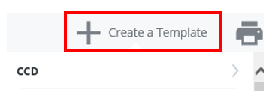

CCD: Cash Concentration and Disbursement typically used to transfer funds between commercial business accounts. This format allows for up to 80 characters of addenda information to accompany the payment.
Child Support: Used for Child Support payments.

CTX: Corporate Trade Exchange typically used to transfer funds between commercial business accounts. This format supports unlimited addenda information to accompany the payment. An example would be expanded remittance information containing payment details and invoice numbers.
PPD: Prearranged Payment and Deposit Entry typically used for payments to consumer accounts or collections from consumer accounts. Examples include payment of direct deposit or collection of dues from individuals.
Tax: Used for the payment of federal tax obligations.

NOTE: Additional payment formats may be available. Please contact your Cash Management Officer if you have questions.

Enter the Template Information:
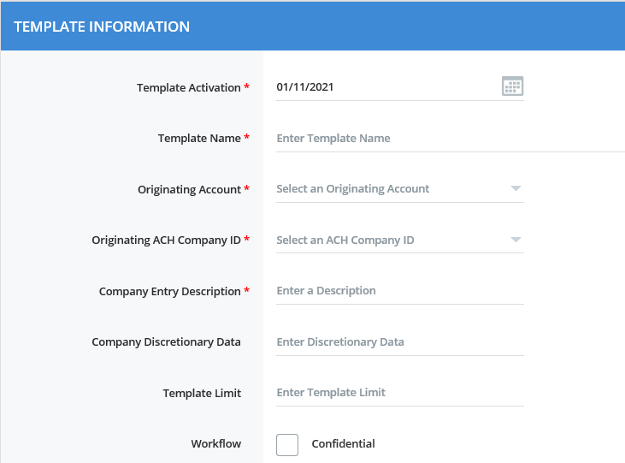
- Template Activation is the date the template is to become active, defaulted to the current day. Future dates are accepted if you wish to start using the template on a set date, but you cannot set a date in the past.
- Template Name (e.g., Payroll). The Template Name may be up to 35 alphanumeric characters, including spaces. Choose a meaningful name to make the template easy to identify.
- Originating Account identifies the account number used.
- Originating ACH Company ID should prefill based on the selection made for Originating Account.
- Company Entry Description is a brief description of the payment, limited to 10 characters. This field cannot be modified when making a payment from the template. The description will show in the Payment Center under Transaction Name/Reference Column. Under the 2026 NACHA Rules, you must now use specific, standardized terms for certain payment types when entering the description:
- PAYROLL: You must use the exact uppercase word “PAYROLL” for any Prearranged Payment and Deposit (PPD) credit entries used to pay wages, salaries, bonuses, commissions, or similar compensation.
- PURCHASE: You must use the exact uppercase word “PURCHASE” for any WEB debit entries authorized by a consumer for an online e-commerce purchase, including recurring purchases first authorized online.
The next several fields are optional, but can be utilized:
- Company Discretionary Data: Used to convey additional information about payments created from the template (up to 20 characters). This field cannot be modified when using the template to make a payment.
- Template Limit: The maximum amount allowed for a payment created from the Template.
- Workflow: Used to designate a template as confidential. When selected, the template may only be viewed by the template creator.

Enter the Recipients information. A recipient is one or more individuals you wish to pay or collect from. You can select from existing recipients already saved in Commercial Center, create new recipients, or import recipient information via a NACHA file.
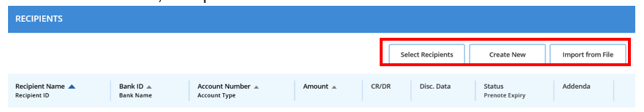
Important Note: Under NACHA’s new risk-based fraud monitoring rules, you must implement procedures to identify potentially fraudulent transactions.
- New Recipients: Before setting up a new Recipient, ensure that you receive the payment routing and account numbers from a trusted, verified source.
- Editing Recipients: Any request to change a Recipient’s bank account information (e.g., via email) must be verified through an independent channel. The change must be verbally confirmed using pre-existing, independently validated contact information prior to updating the Template.

When creating a new Recipient, click Create New and enter the following:
- Recipient Name: The name of the company or individual that you are paying or collecting funds from
- Recipient ID: An identifier that identifies the recipient.
- Account Type: Select Savings or checking.
- Account Number: Recipient’s account number.
- Bank Information: Recipient’s bank routing number. You may either select a bank from the Preferred/Standard Bank lists or select Enter Bank Information option to enter the Bank ID or name. To search for Central Bank, enter Central Bank * (two spaces before the asterisk). Verify that Central Bank’s routing number 042100146 is displayed.

Options. You may also choose to:
- Save to Master List Recipient List
Add the recipient to the list so it may be used in other payments. Be sure to select the appropriate payment types where the recipient can be used.
- Add Contact
Store other contact information for the recipient (e.g., address details, email).
- Add as Secondary Account Information
For PPD recipients a secondary account can be defined so that a portion of each payment amount is allocated to that account, with the remainder sent to the primary account. The allocation amount may be a pre-set dollar amount or a percentage of the recipient payment amount.
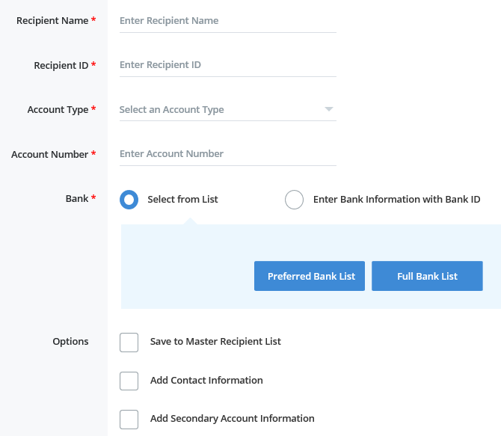

Once all information has been entered, click Continue.

A Preview Recipient box will appear. Once the information has been verified, select Submit to save the information entered, or Submit and Create to add another Recipient.

Creating a Batch from a Template

To access an existing template, select Payments.

Select Create ACH Payments, then From Template or select Manage, Template Center.

Click the blue Template name to access the template.

Scroll to the Recipients list. All recipients in the listing are displayed. To modify the recipients in your listing, you may:
- Select Recipients
Choose the specific recipients to be included. Place a check mark in the box by each name and click Done.
- Create New
Create and add a new recipient.
- Import from File
Import a listing of recipients from an existing file. The first time you import recipients, an Import Profile must be created and saved to use during the import process. See Import below.

Under Amount, enter the amount of the transaction for each recipient.
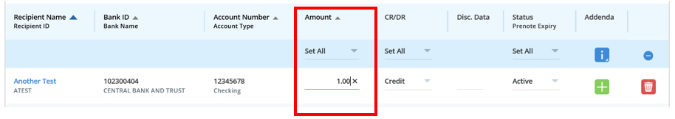

Under CR/DR, verify that the correct action is designated, either crediting or debiting the receiving account.

The dropdown under Status enables you to designate the recipient’s transaction as Active, Hold or Prenote.

Addenda allows you to include additional information with the transaction. The number of characters allowed for addenda information is determined by the ACH payment type selected when creating the template.
Depending on your company setup, addenda options may include:
- FRF – Freeform
Input up to 80 characters of freeform addenda
- NTE – Note/Special Instruction
Defined as Change, Invoice Instruction, Line Item, Other Instructions, Payment or Mutually Defined plus a Description
- REF – Reference Number
Includes Reference Number Qualifier, Reference Number ID and Description
- RMR – Remittance Advice
Invoice-related fields such as: Invoice Amount Paid, Original Invoice Amount, Discount Amount, Adjustment Amount, Adjustment Reason Code
- TRN – Trace
Current Transaction Trace Number, Referenced Transaction Trace Number, Reassociation Trace Number

Click Continue.

A Preview Template page will appear. Verify the information, then select Submit Template.

A message will appear at the bottom of the screen that will indicate if the template has been successfully submitted.

Click on Template Center.

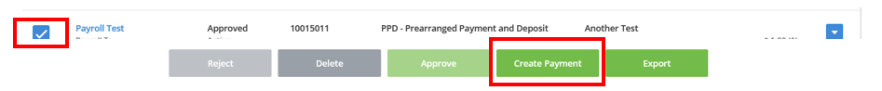
Enter a check mark next to the transaction, and select Create Payment.

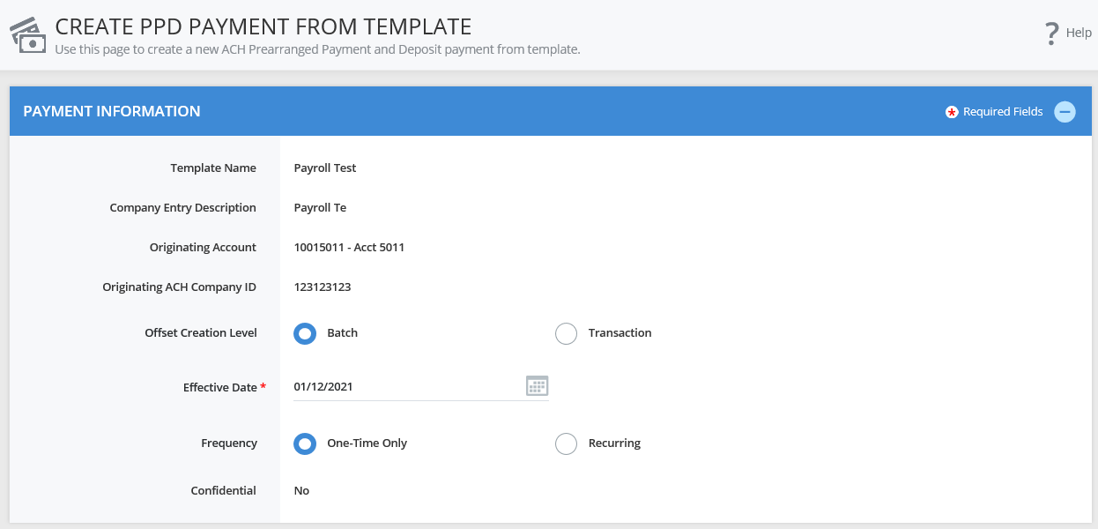
Next, the Create Payment from Template screen will display. Review the information, and make any necessary changes.

- The Offset Creation Level should always be set to Batch. Transaction is never the correct choice.
- Change the Effective Date if the pre-filled date is incorrect (the system defaults to the next day).
- Frequency If this is a recurring payment, select Recurring and enter the information accordingly.
Recurring payment options:
- Processed on a schedule of daily, weekly, monthly, or yearly options
- Processed a specified number of times
- Until further notice – payment will continue until it is manually deleted
- Until a specified date

Verify the Recipient Information once more.

Select Continue to preview the payment.

Click Submit Payment.

After clicking Submit, a confirmation will appear at the bottom of the screen.

If Workflow – Approve on Submit is not enabled, go to Payment Center to approve the transaction.

Put a checkmark next to the transaction. Click the blue View Recipients to review recipients and details of payments to be approved. Click Cancel to return to the approval process.

Click Approve. (if this selection is grayed out, you do not have permission to approve a transaction).

The security code from a Mobile Token is required to release an ACH transaction. Enter the six-digit security code from your security token.

If an additional approver is required, that approver must access, approve, and submit the payment.

A confirmation will appear at the bottom of the screen once approved and submitted.

Editing a Template
Numerous edits may be made to a template. Common edits include modifying payment amounts or updating recipient banking information.

Click Payments.

Click Manage, Template Center.

Click on the blue Template name.

Enter the updated information for either Template Information or for Recipients. Examples of Recipient edits include: changing the dollar amount under Amount, or clicking the Recipient Name to edit bank information.

Once the edits are complete, click Continue.

Click Submit Template.

ACH Quick Entry
Use ACH Quick Entry to re-create a payment for the same account, same end recipient, and same amount, with only the new payment date being changed.
When using ACH Quick Entry, you cannot edit the template, including the Company Account, Template Type, Recipient or Payment Amount.

Click Payments.

Click ACH Quick Entry under Create ACH Payments.

Select one or more templates you would like to re-create, enter an effective date for each, review the Recipients for accuracy and click Continue.
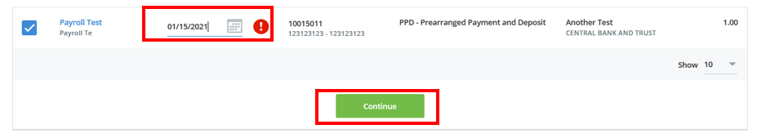

Click Submit Payment.
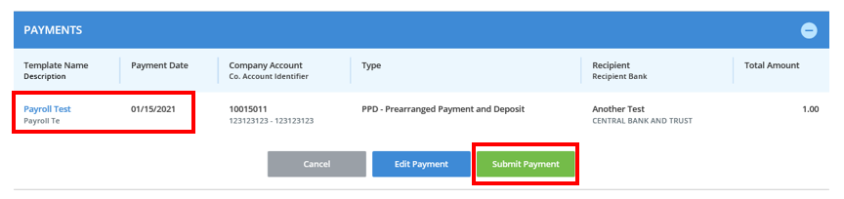

If Workflow – Approve on Submit is not enabled during the template creation, go to Payment Center to approve the transaction.

Put a checkmark next to the transaction. Click the blue View Recipients to review recipients and details of payments to be approved. Click Cancel to continue the approval process.

Click Approve. (if this selection is grayed out, you do not have permission to approve a transaction).

The security code from a Mobile Token is required to release an ACH transaction. Enter the six-digit security code from your security token.

If an additional approver is required, that approver must access, approve, and submit the payment.

A confirmation will appear at the bottom of the screen once approved and submitted.

Prenotes
Utilizing prenotes is recommended as an effective, zero-dollar risk-based procedure to validate bank account information and mitigate risk of False Pretenses fraud prior to issuing a payment.

Access the Recipient information by clicking on Payments, Manage, Template Center

Click the blue Template name.

For the specific recipient, select Prenote under Status.

For additional recipients listed in the template that do not require a prenote, select Hold under Status.

Click Continue.
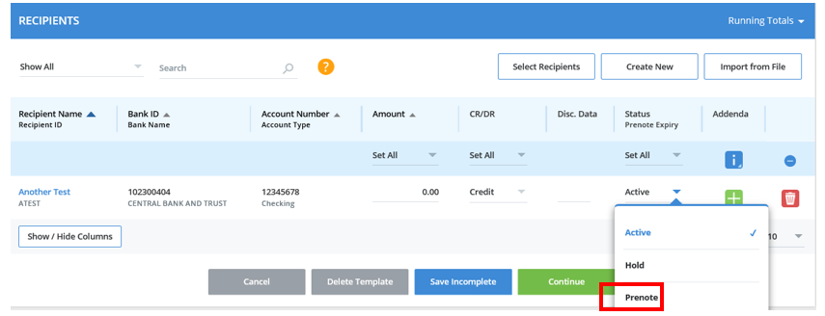

Click Submit Template.

A confirmation will appear.

If Workflow – Approve on Submit is not enabled during the template creation, go to Payment Center to approve the transaction

Put a checkmark next to the transaction, and click Approve (if this selection is grayed out, you do not have permission to approve a transaction).

The security code from a Mobile Token is required to release an ACH transaction. Enter the six-digit security code from your security token.

If an additional approver is required, that approver must access, approve, and submit the payment.

A confirmation will appear at the bottom of the screen when approved and submitted.

Export

Click Payments, Manage, then Payment Center.

Place a check mark next to the payment.

Click Export.

You may export the following:
- All Recipients
- Active & Prenoted Recipients
- Active Recipients

Approve Payments

Click Payment, then Payment Center.

Place a check mark next to the transaction.

Click the blue View Recipients to review recipients and details of payments to be approved. Click Cancel to continue the approval process.

Click Approve.

Enter the passcode from the security or mobile token.

A confirmation will appear.
A second path to Approvals is available in the top header bar. Click the number displayed beside Approvals.

ACH File Import and ACH File Upload
ACH File Import and ACH File Upload enable direct import of NACHA files saved from your accounting software into the system. See outlined below the differences between the two methods. During the implementation process, your Cash Management Officer will assist in determining the method most compatible with your company’s procedures.
As noted above, you must ensure your software is updated to include the exact words “PAYROLL” or “PURCHASE” in the Company Entry Description field for applicable transactions prior to uploading. If third-party software is utilized to generate your ACH import files, you should leverage business analytics, alerts, and anomaly detection tools within the software to review imported files for unusual payment amounts or unknown recipients before final approval.
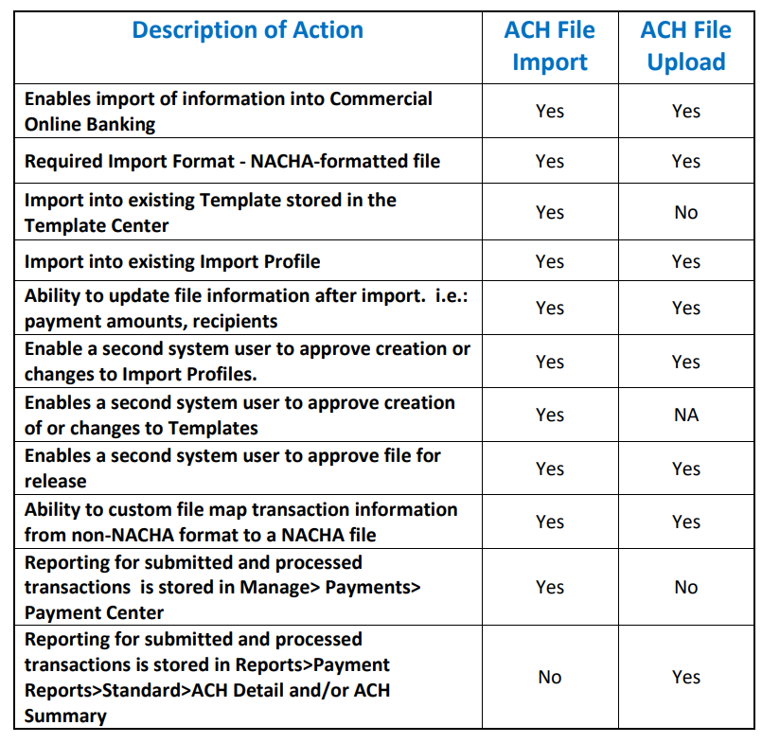

ACH File Import – Recipients

Create a NACHA file within your accounting software.

Log into Commercial Online Banking Business.

You must have an ACH Template created for the imported file. To create an import template, see directions above in Creating a Template.

You must also have a Profile defined for the import. See directions below to Create an Import Profile.
Click Payments, Manage, Template Center.

To import recipients, click the blue template name (e.g., Payroll).

Under Recipients, choose Import from File.

In the Profile list, choose the associated profile for the transactions.

Click Next.

Click Browse, search your computer files and select the NACHA file created.

Click Next.

Review the Recipient Information to ensure all amounts are correct.

Select Import File.

You can also select Save all imported recipients to the master list, so that information is stored in the Payment Center.

Click Continue.

Click Submit Template.

Next, click Payments → Payment Center.

Enter a check mark beside the payment created.

Click Approve (if this selection is grayed out, you do not have approval authority).

Enter the passcode from your Security or Mobile Token.

A confirmation will appear confirming the transaction was created successfully.

Creating an Import Profile – Recipients

Click Payments, Payment Tools, Import Profiles

Click Create Profile

Enter Profile Name

Select a File Format. If your accounting system can create a NACHA-formatted file, choose ACH NACHA. If your account system cannot create a NACHA-formatted file, choose ACH User-Defined. Please contact Corporate Services, at 859-253-8743, for assistance in creating your User-Defined profile.

Click Next.

You may import either: Non-Repetitive Payments, Templates or Recipients. Click Recipients to import into a Template listing Recipients.

Offset Creation Level – Always Batch.

Profile Access – Choose either Private or Public, depending on whether others within your organization should view it.

Options
- Check for duplicate files and reject duplicates
- Check record count
- Check hash totals

Click Next.

Click Submit Profile.

NOTE: You may also import listings of Non-Repetitive Payments or Templates. Profiles must be created separately for each of these specific file types.

ACH File Upload

Create a NACHA file within your accounting software.

Log into Commercial Online Banking Business.

To upload the ACH file into the Profile, click on File Services, then Manage File Uploads.

Click Upload File.

Click the arrow next to Upload Type and choose ACH (Standard).

(NOTE: ACH (Standard) is used for a NACHA file. If your file is not a NACHA file, contact Corporate Services at 859-253-8743).

Click Next to continue to Step 2.

Click Browse to locate the NACHA file on your computer. If you would like the system to check for duplicate files and reject the duplicates, check the box next to Duplicate File Check.

Click Upload to load the file.

Next, click Payments → Payment Center.

Enter a check mark beside the payment created.

Click Approve. If you do not have approval authority, this will be grayed out.

Enter the passcode from your Security or Mobile Token.

A confirmation will appear confirming the transaction was created successfully.

Manage File Uploads

Click on File Services, Standard File Uploads, Manage File Uploads to review the file.

From the Manage File Uploads page you may:
- View content details of the uploaded file by clicking the blue hyperlink file name;
- Approve uploads, but only if you are designated as an Upload Approver and did not create the upload;
- Transmit upload files to the bank;
- Click Refresh Data to retrieve the most recent information;
- Delete uploads that have not yet been transmitted.

Use the Search fields to search by File Name or Date Range. Click Search to locate the file.

You may check the box next to a file that has not been submitted to edit a file, view previously submitted files, approve, transmit or delete.

General Information

Central Bank Holiday Schedules
The Bank does not originate, receive, or otherwise process ACH transactions on any federal holiday or on any day the Federal Reserve is closed. ACH files submitted on such days will be deemed received on the next Business Day on which the Federal Reserve is open for ACH settlement and processed in accordance with the Bank’s cutoff times and funds availability schedule. A list of Bank holidays for calendar year 2026 is available at the following link: federal-reserve-holidays-2026.pdf.

NOTE: For holidays falling on Saturday, Federal Reserve Banks and Branches will be open the preceding Friday. For holidays falling on Sunday, all Federal Reserve Banks and Branches will be closed the following Monday.
NOTE: ACH transactions should not have an effective date for any of the Federal Reserve Holidays.
ACH File Cut-Off
ACH File Cut-off is 5:00 PM ET. Files with the Effective Date of the next business day must be released before 5:00 PM ET on the current business day.
Same Day ACH: ACH File Cut-off for Same Day ACH is 12:00 PM ET and the amount of the payment must be less than $50,000. If you need to originate a Same Day ACH, contact Central Bank’s Corporate Services Department at 859-253-8743 prior to doing so. If you fail to contact us prior to originating the payment, your transactions may be processed on a next-day basis.

Mobile Token
Install the Mobile Token on your phone to obtain the security code to access Commercial Online Banking and the associated Mobile App.
To install your Mobile Token, follow the directions listed below.

From the App Store or Google Play, search and download the VIP Access App in the app store.
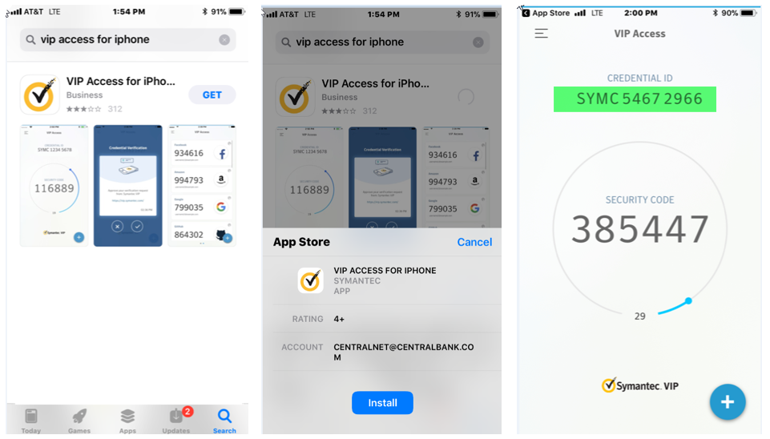

Once downloaded, log in to Commercial Banking Online, and select Activate Token located under Other Settings and Preference in the Welcome menu.

Three pieces of information are required:

Activation Code: central2021

Token Number: Credential ID listed on the mobile app

Passcode: Six-digit number generated by the app

Additional Information
If you have any problems processing your ACH transactions, please call Commercial Online Banking Client Services at 859-253-6338 or Central Bank’s Corporate Services Department at 859-253-8743. Office Hours are Monday-Friday 8am-5pm.

0002006.0656700 4936-9331-2148v6

